Experiment No.

Steps & Screenshots:

**Step1:** Create a new Instance

* 1. Goto EC2 console and click on Launch Instance

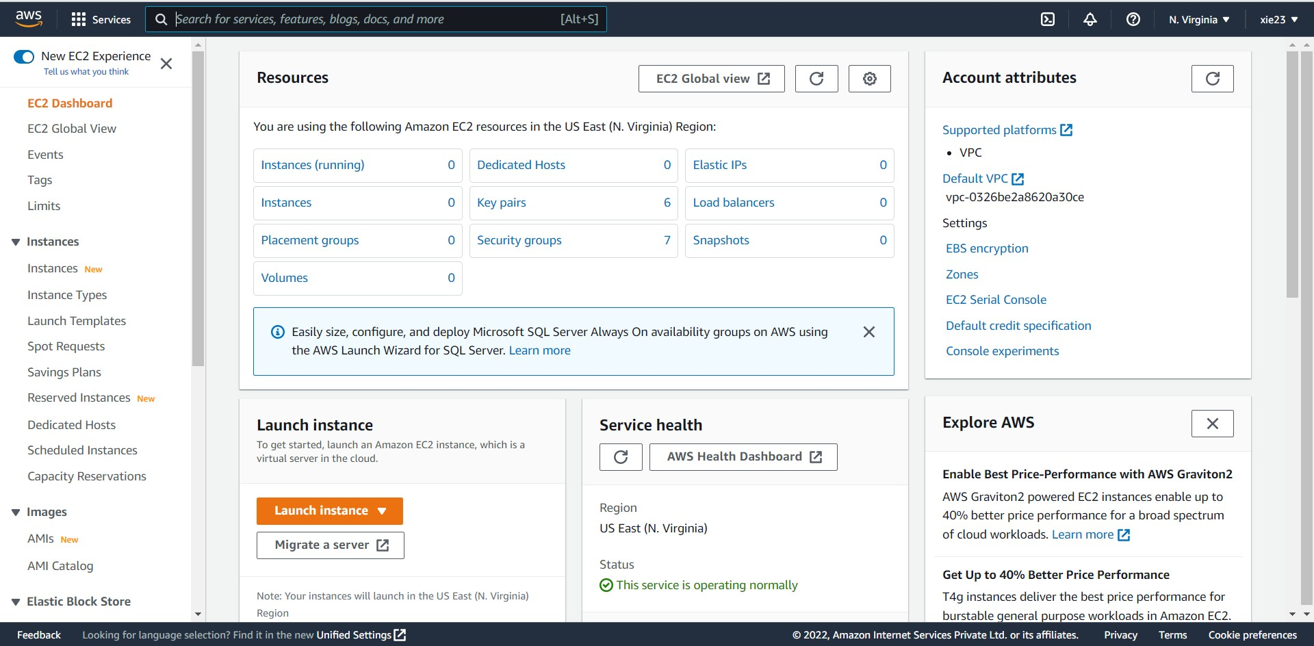

* 1. 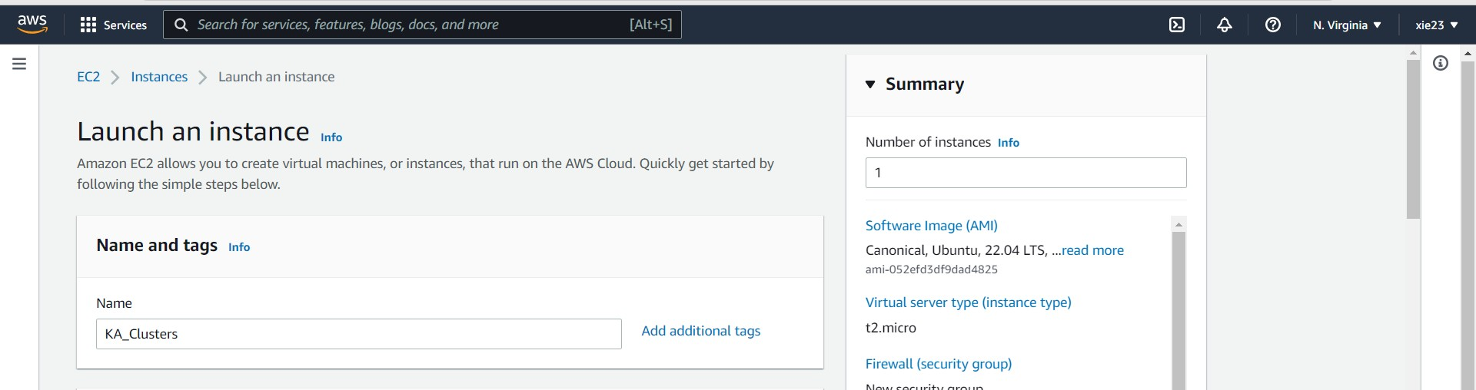Give the name to your instance
  2. Choose Ubuntu OS

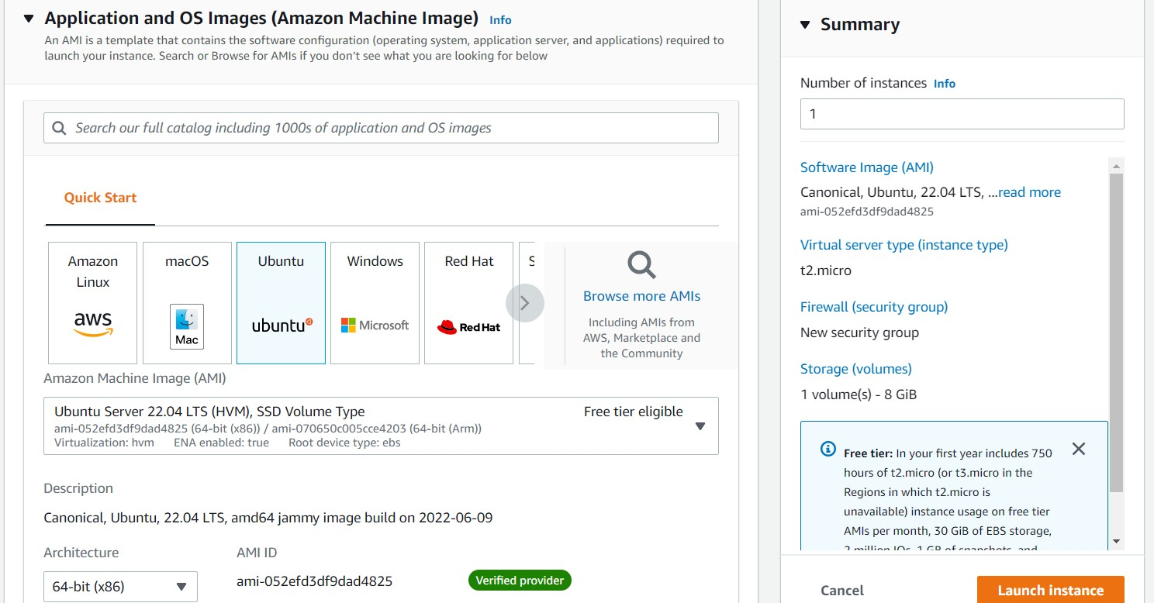

* 1. 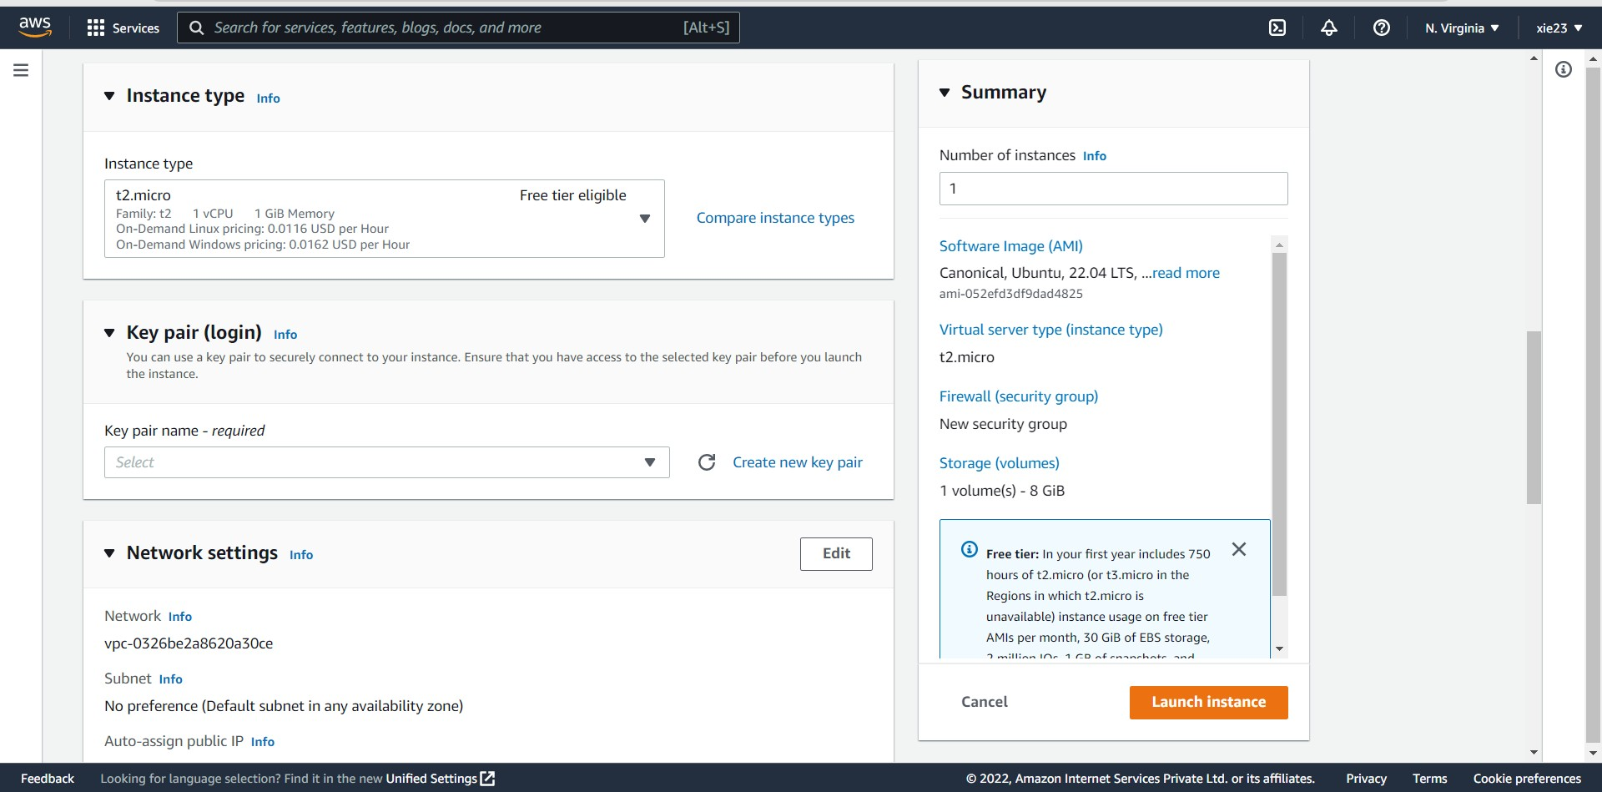Click on Create new key pair
  2. Give the Key pair name and select .ppk file format and then click on Create key pair

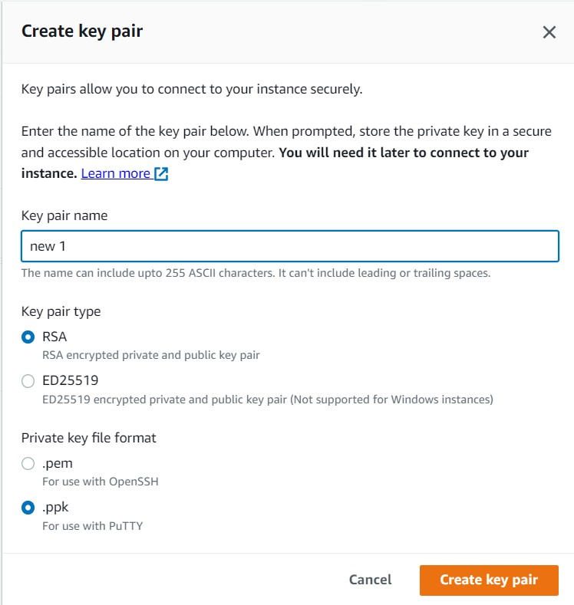

* 1. Click on Launch Instance

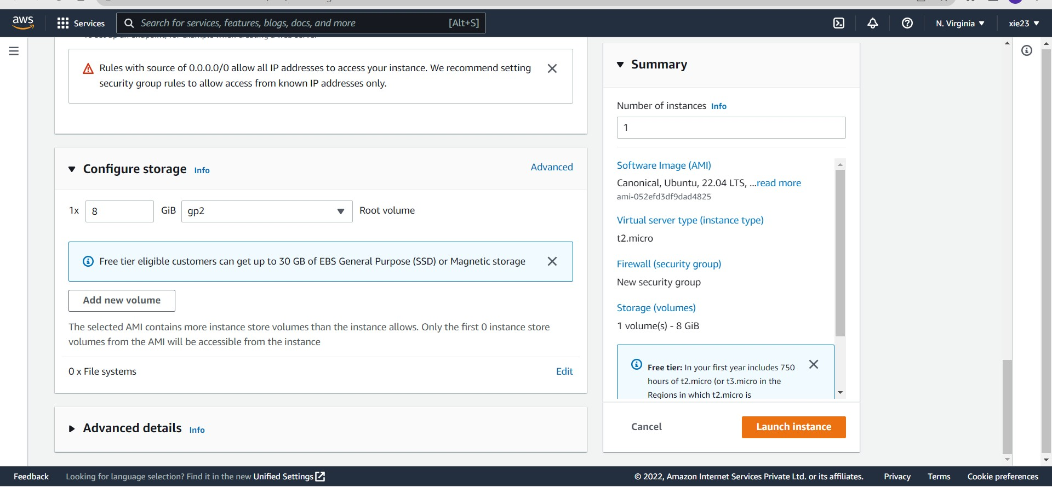

* 1. Successfully instance is launch

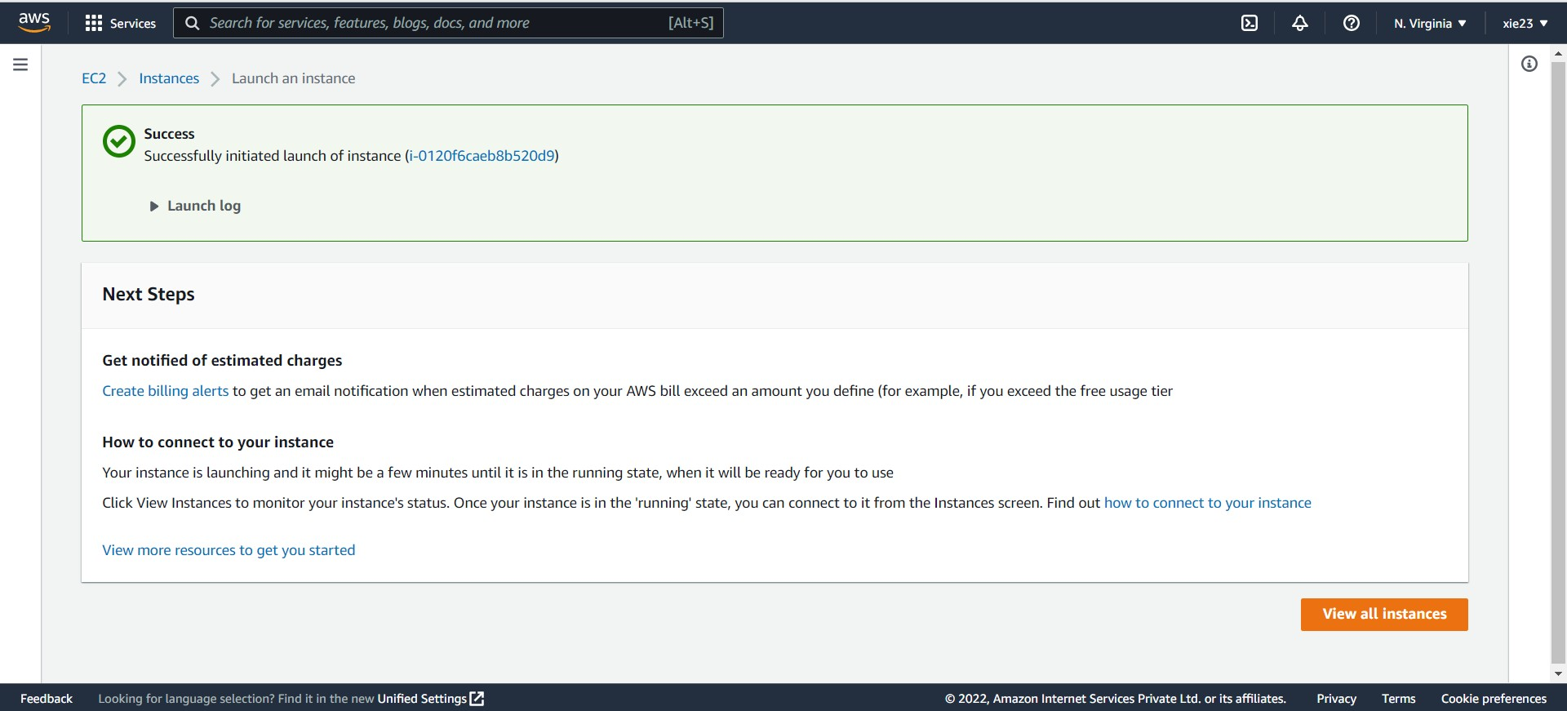

**Step 2:** Connection

1. 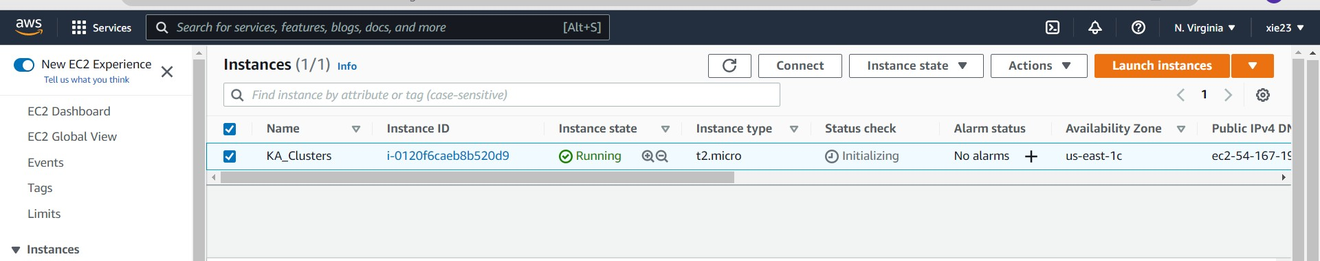Goto Instances and select the newly created instance and then click on connect
2. Click on Connect

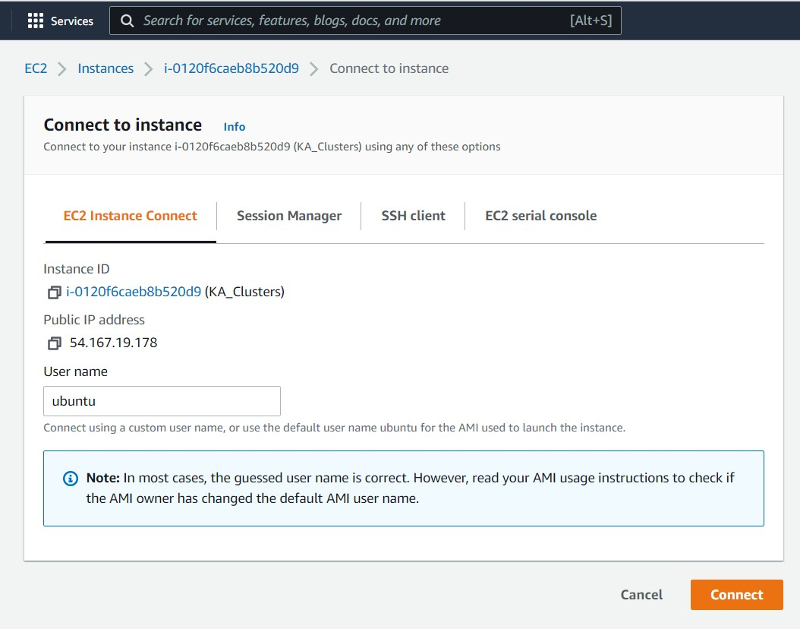

1. Establishing Connection

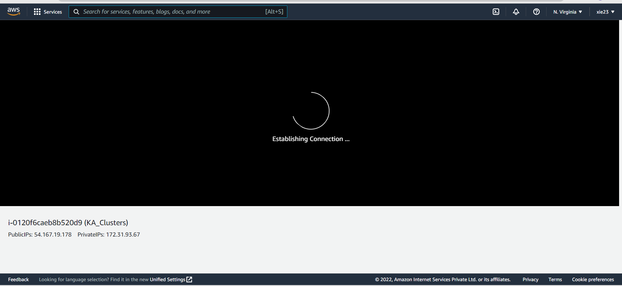

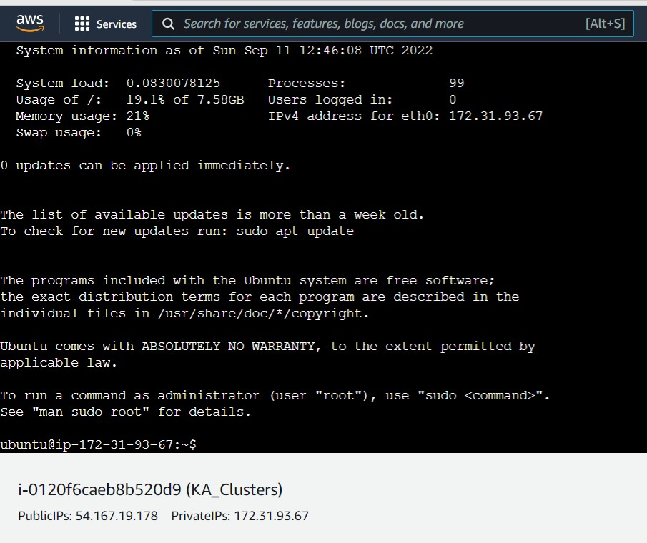

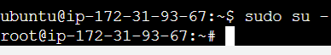**Step 3:** Run the command “ sudo su -” to goto root

**Step 4:** Install all the updates

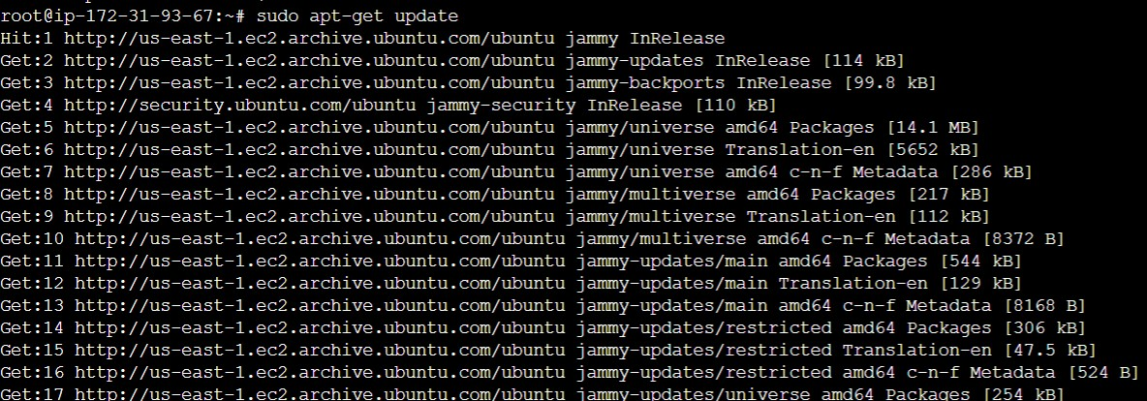

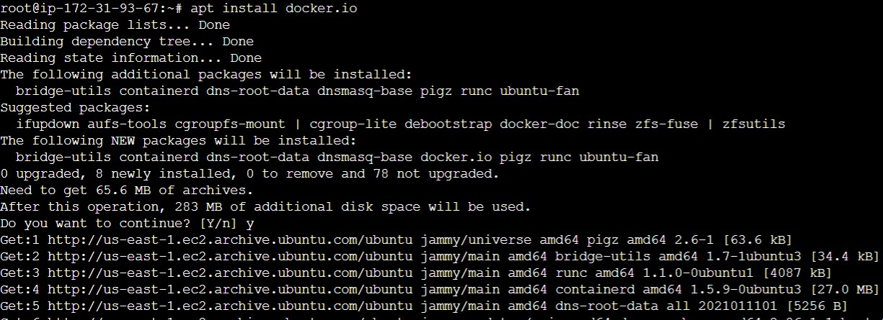**Step 5:** Install Docker and check its version

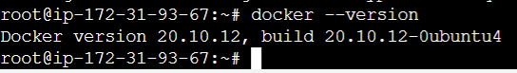

**Step 6:** Enable Docker and then check docker status

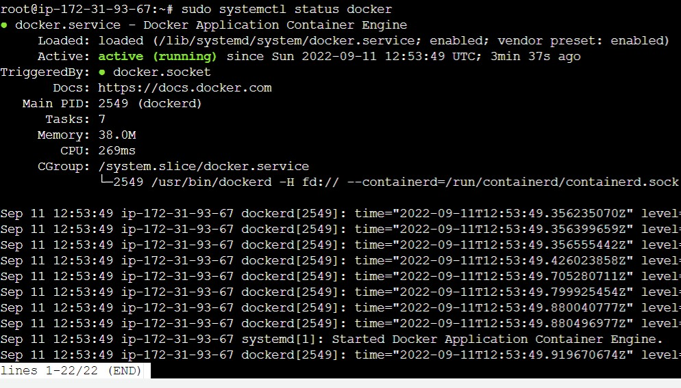

**Step 7 :** Curl

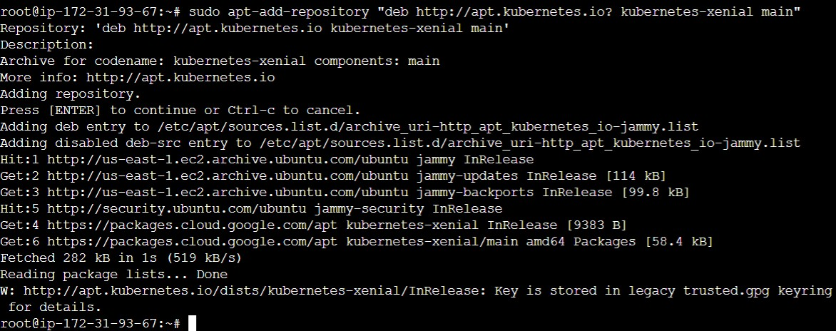**Step 8:** Add repository

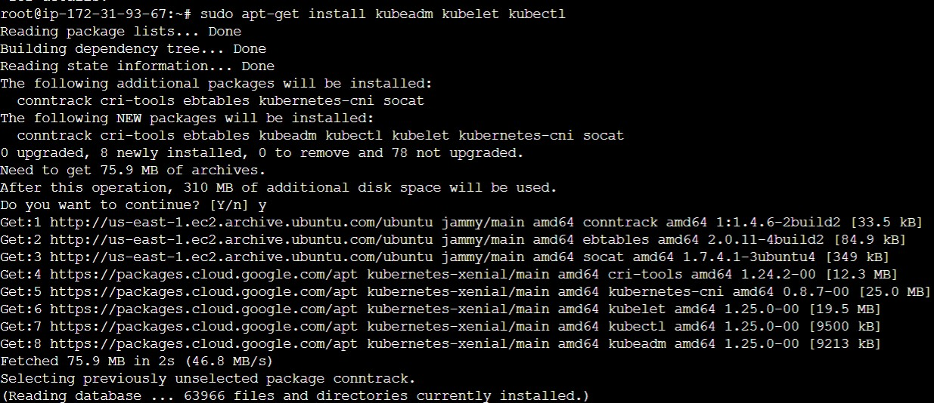**Step 9:** Install Kubeadm

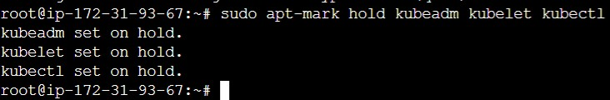**Step 10:** Set on hold

**Step 11:** Check kubeadm version

